COURSE CODE : ITA1430
COURSE NAME : ETHICAL HACKING

EXPERIMENT – 8
Nmap Service Version and OS Detection
Aim
To perform service version detection and operating system identification using Nmap.
Theory
Nmap (Network Mapper) is an open-source network scanning tool used for network discovery and security auditing.
Commands
i) Detect Service Versions
nmap -sV 192.168.1.10
Description:
Determines the versions of services running on target ports.
ii) Aggressive Scan
nmap -A 192.168.1.10
Description:
Performs OS detection, version detection, script scanning, and traceroute.
iii) Operating System Detection
sudo nmap -O 192.168.1.10
Description:
Identifies the operating system running on the target host.
Sample Output
PORT STATE SERVICE VERSION
22/tcp open ssh OpenSSH 8.2
80/tcp open http Apache 2.4

Output:
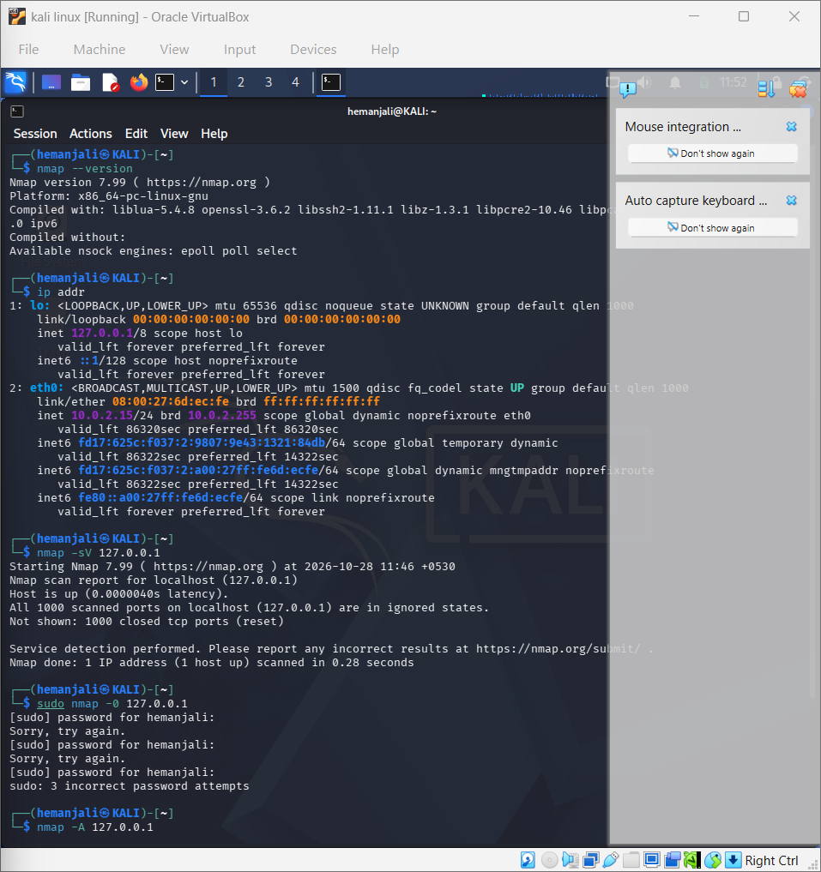
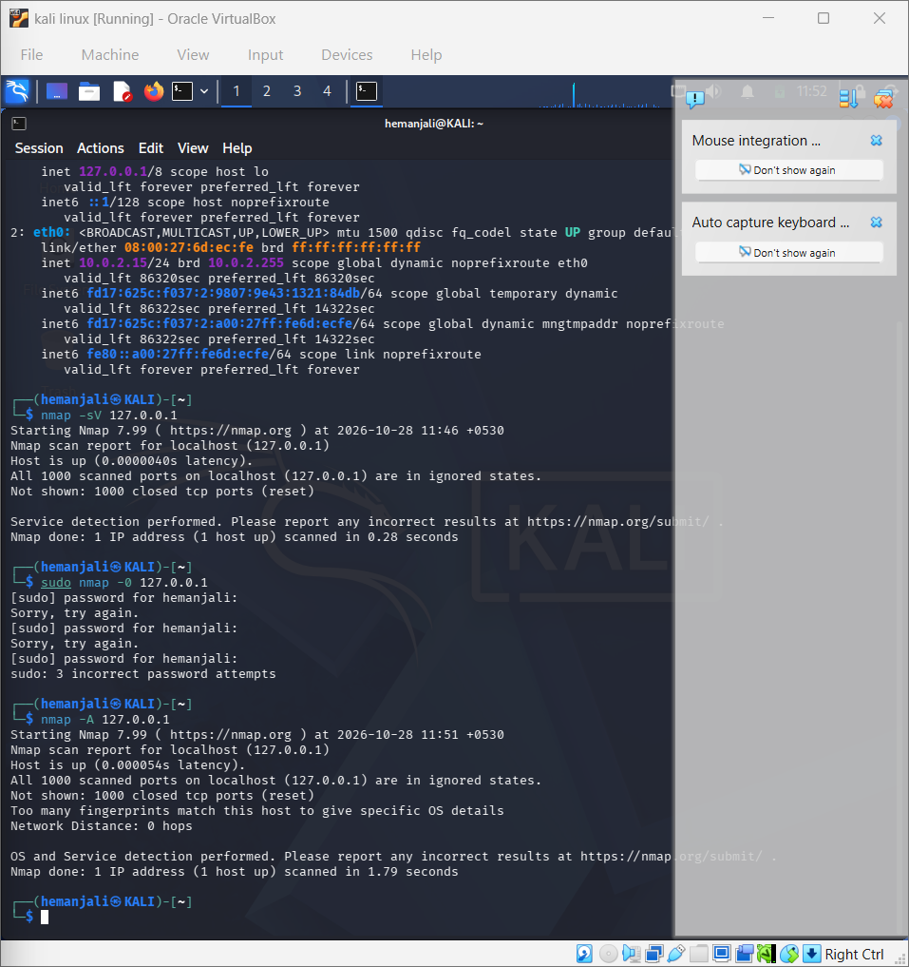
Result
Successfully performed service version detection and OS identification using Nmap.

